Scrum is a framework for developing and sustaining complex products. Ken Schwaber and Jeff Sutherland developed Scrum. Together, they stand behind the Scrum Rules.

Scrum Definition

Scrum is a framework within which people can address complex adaptive problems, while productively and creatively delivering products of the highest possible value.

Scrum is a process framework that has been used to manage complex product development since the early 1990s. Scrum is not a process or a technique for building products; rather, it is a framework within which you can employ various processes and techniques. Scrum makes clear the relative efficacy of your product management and development practices so that you can improve.

The Scrum framework consists of Scrum Teams and their associated roles, events, artifacts, and rules. Each component within the framework serves a specific purpose and is essential to Scrum’s success and usage.

The rules of Scrum bind together the events, roles, and artifacts, governing the relationships and interaction between them. The rules of Scrum are described throughout this tutorial.

**Note** - Across the industry, there are misconceptions that Scrum means no documentation, scrum team consists of only developers, and so on. It is not entirely so; we will give clarifications on these in later sections.

Scrum Process Framework

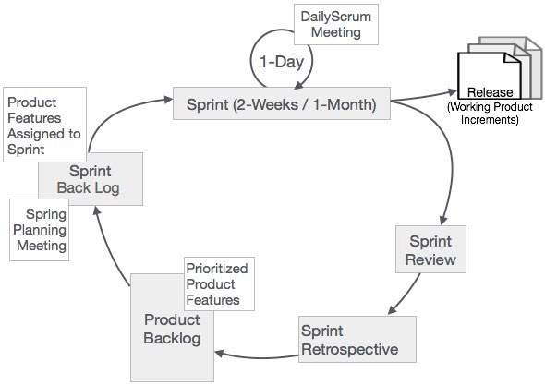

In Scrum, the prescribed events are used to create regularity. All events are time-boxed events, such that every event has a maximum duration. The events are described more elaborately in the subsequent chapters.

Sprint

The heart of Scrum is a Sprint, a time-box of two weeks or one month during which a potentially releasable product increment is created. A new Sprint starts immediately after the conclusion of the previous Sprint. Sprints consist of the Sprint planning, daily scrums, the development work, the Sprint review, and the Sprint retrospective.

* In Sprint planning, the work to be performed in the Sprint is planned collaboratively by the Scrum Team.
* The Daily Scrum Meeting is a 15-minute time-boxed event for the Scrum Team to synchronize the activities and create a plan for that day.
* A Sprint Review is held at the end of the Sprint to inspect the Increment and make changes to the Product Backlog, if needed.
* The Sprint Retrospective occurs after the Sprint Review and prior to the next Sprint Planning. In this meeting, the Scrum Team is to inspect itself and create a plan for improvements to be enacted during the subsequent Sprint.

Conclusion

Scrum is a process framework that defines certain rules, events, and roles to bring in regularity. However, it can be adapted to any organization, based on needs, provided the basic scrum rules are not violated.

The Scrum Team consists of three roles, namely a ScrumMaster, a Product Owner, and the Team.

ScrumMaster

The ScrumMaster (sometimes written as the Scrum Master, although the official term has no space after “Scrum”) is the keeper of the scrum process. He/she is responsible for-

* making the process run smoothly
* removing obstacles that impact productivity
* organizing and facilitating the critical meetings

Product Owner

The Product Owner is responsible for maximizing the value of the product and the work of the Team. How this is done may vary widely across organizations, Scrum Teams, and individuals.

The Product Owner is the sole person responsible for managing the Product Backlog. Product Backlog management includes-

* Expressing Product Backlog items clearly.
* Ordering the Product Backlog items to best achieve goals and missions.
* Optimizing the value of the work the Team performs.
* Ensuring that the Product Backlog is visible, transparent, and clear to all, and shows what the Team will work on further.
* Ensuring that the Team understands items in the Product Backlog to the level needed.

The Product Owner may do the above work, or have the Team do it. However, the Product Owner remains accountable for these tasks.

The Product Owner is one person, not a committee. The Product Owner may represent the desires of a committee in the Product Backlog, but those wanting to change a Product Backlog item’s priority must address the Product Owner.

For the Product Owner to succeed, the entire organization must respect his or her decisions. The Product Owner’s decisions are visible in the content and ordering of the Product Backlog. No one is allowed to tell the Team to work from a different set of requirements, and the Team is not allowed to act on what anyone else says. This is ensured by ScrumMaster.

The Team

The Team is self-organizing and cross-functional. That means the team comprises of analysts, designers, developers, testers, etc. as appropriate and as relevant to the project.

Some people in the industry refer to this team as development team. However, such a reference is leading to controversy that the team can have only developers and no other roles. It is an obvious understanding that it is only a misconception. To develop a software product, we require all the roles and that is the essence of scrum – the team will function in collaboration. Cross-functional teams have all competencies needed to accomplish the work without depending on others not part of the team, and thus time and effort can be saved. The team model in Scrum is designed to optimize flexibility, creativity, and productivity.

Optimal Team size is small enough to remain nimble and large enough to complete significant work within a Sprint. The Team size should be kept in the range from five to nine people, if possible. Fewer than five team members decrease interaction and results in smaller productivity gains. Having more than nine members requires too much coordination.

The scrum team works together closely, on a daily basis, to ensure the smooth flow of information and the quick resolution of issues. The scrum team delivers product iteratively and incrementally, maximizing opportunities for feedback. Incremental deliveries of a complete product ensure a potentially useful version of working product is always available.

ScrumMaster is a trained responsible person, who renders services as described below -

## ScrumMaster Services to the Product Owner

The ScrumMaster serves the Product Owner in several ways, including -

* Finding techniques for effective Product Backlog management.
* Helping the Scrum Team understand the need for clear and concise Product Backlog items.
* Understanding product planning in an empirical environment.
* Ensuring that the Product Owner knows how to arrange the Product Backlog to maximize value.
* Understanding and practicing agility.
* Facilitating Scrum events as needed.

## ScrumMaster Services to the Scrum Team

The ScrumMaster serves the Scrum Team in several ways, including -

* Coaching the Scrum Team in self-organization and cross-functionality.
* Helping the Scrum Team to create high-value products.
* Removing impediments to the Scrum Team’s progress.
* Facilitating Scrum events as requested or needed.
* Coaching the Scrum Team in organizational environments in which Scrum is not yet fully adopted and understood.

## ScrumMaster Services to the Organization

The ScrumMaster serves the organization in several ways, including-

* Leading and coaching the organization in its Scrum adoption.
* Planning Scrum implementations within the organization.
* Helping employees and stakeholders understand and enact Scrum and empirical product development.
* Causing change that increases the productivity of the Scrum Team.
* Working with other ScrumMasters to increase the effectiveness of the application of Scrum in the organization.

## Conclusion

Scrum is a process framework that defines certain rules, events, and roles to bring in regularity. However, it can be adapted to any organization, based on needs, provided the basic scrum rules are not violated.